**EXPERIMENT NUMBER: 5**

**AIM OF THE EXPERIMENT:** Measurement power in a 3-phase circuit

**OBJECTIVE**: To measure power in a 3-phase load by two wattmeter methods.

**APPARATUS REQUIRED:**

|  |  |  |  |
| --- | --- | --- | --- |
| Sl. No. | Instrument Name | Specification | Quantity |
| 1 | Wattmeter | - | 2 |
| 2 | A.C Voltmeter | - | 1 |
| 3 | A.C Ammeter | - | 1 |
| 4 | Resistors | - | 3 |
| 5 | Inductance | - | 3 |
| 6 | A.C Voltage Source | 440 V, 50 Hz | 1 |

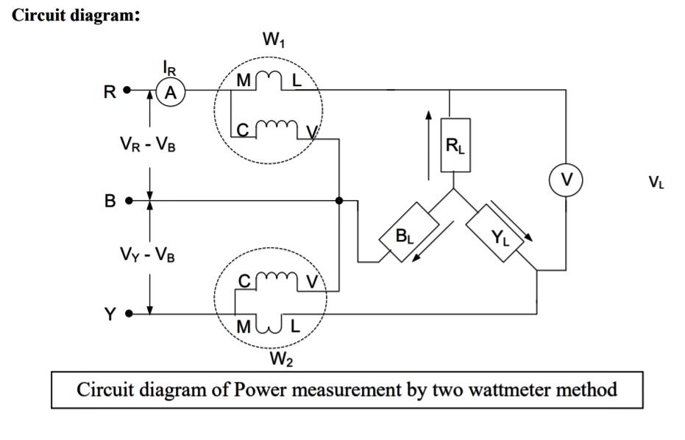

**OBSERVATION TABLE:**

|  |  |  |  |  |  |  |  |
| --- | --- | --- | --- | --- | --- | --- | --- |
| SL. NO | LINE CURRENT (IL) in Amp | LINE VOLTAGE (VL)2 in Volt | 1st Wattmeter reading (W1) in watt | 2nd Wattmeter reading (W2) in watt | POWER= W1+W2 | Φ = | P.F= cosφ |
| 1 | 5.081 | 440 | 1936 | 1936 | 3872 | 0 | 1 |
| 2 | 2.54 | 440 | 0.05042 | 968 | 968.05042 | -1.047 | 0.500 |
| 3 | 1.738 | 440 | -132.7 | 585.7 | 453 | -1.222 | 0.342 |
| 4 | 3.811 | 440 | 1452 | 1936 | 3388 | -0.243 | 0.971 |
| 5 | 2.324 | 440 | 135.1 | 89.2 | 224.3 | 0.341 | 0.943 |
| 6 | 1.664 | 440 | -52.47 | 555.7 | 503.23 | -1.125 | 0.431 |

**Phasor Diagram:**

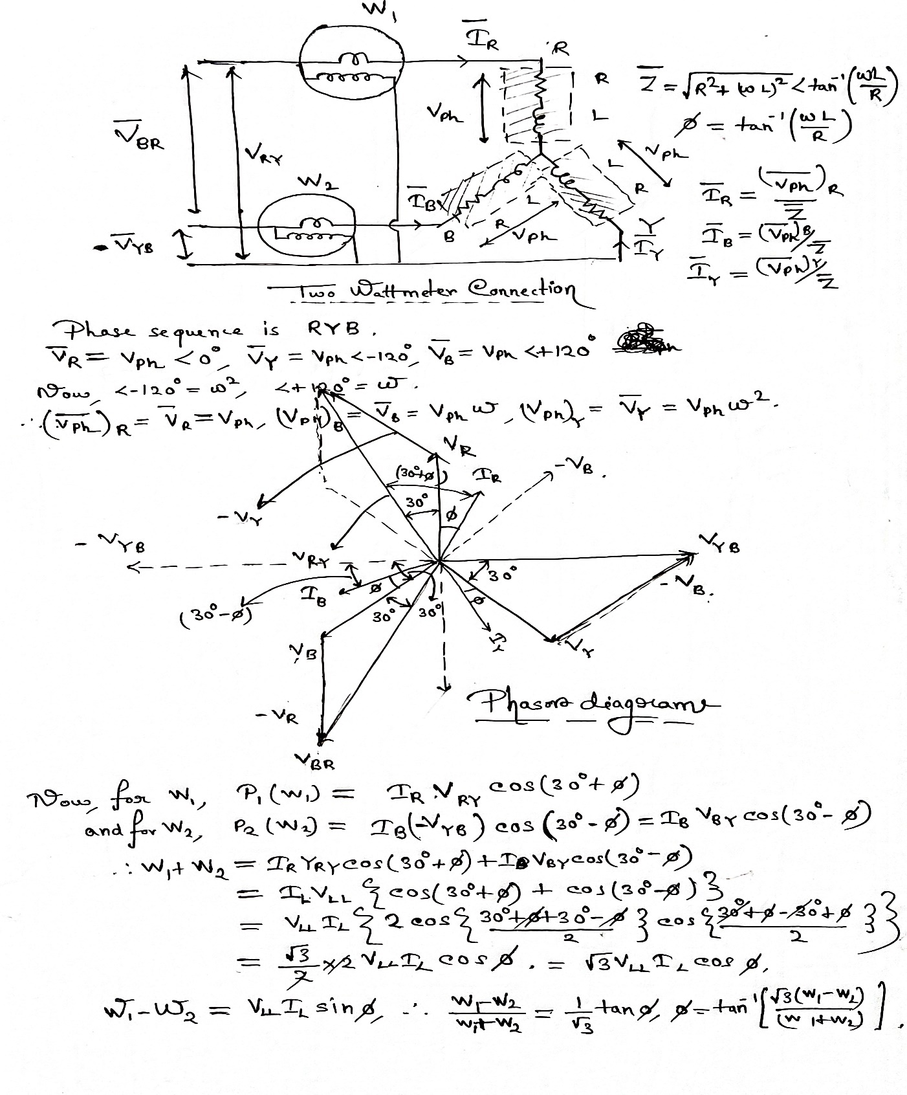

**Questions**

* Establish that power factor may also be estimated from two wattmeter readings.

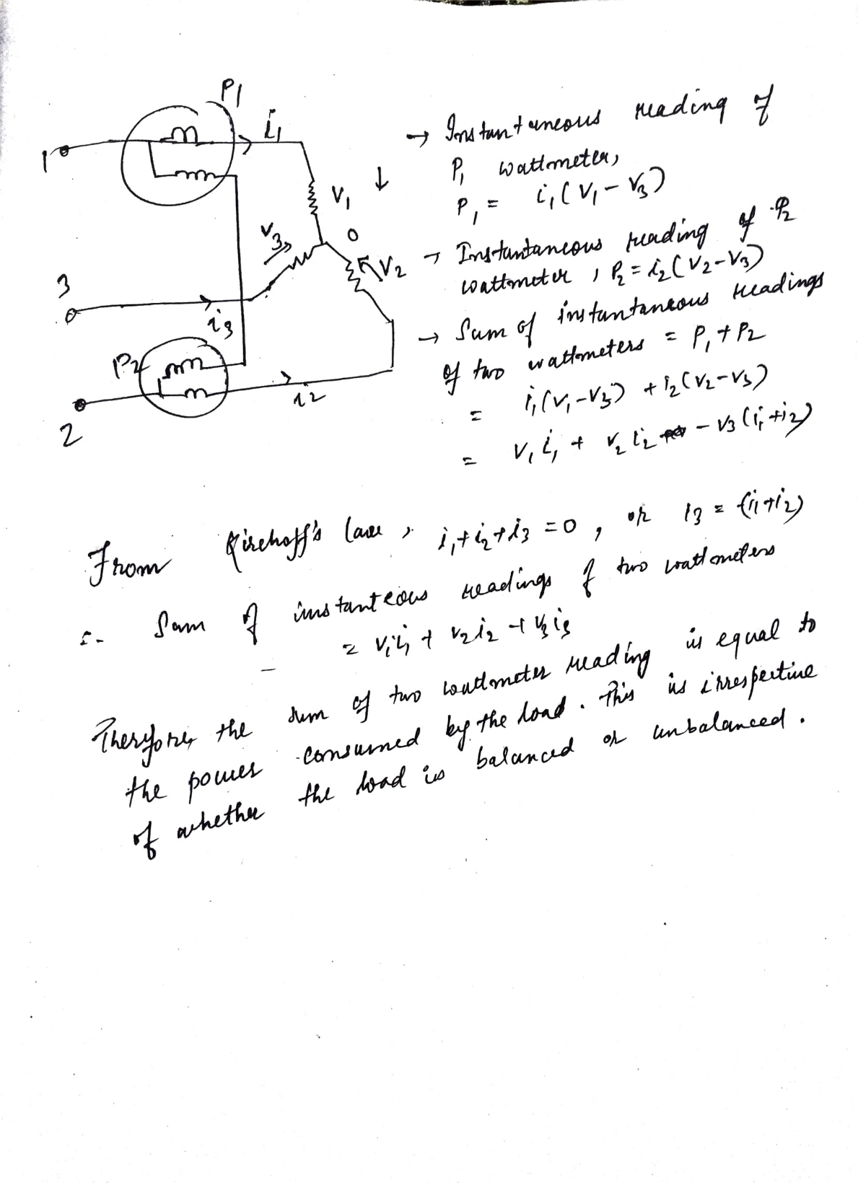

* Explain why the wattmeter will give (a) zero reading (b) negative reading.

The reading of a wattmeter is proportional to (current through the current coil) x (voltage across the pressure coil) x Cosine (angle between this current and this voltage). Depending on the value of the cosine the wattmeter reading can be zero or negative.

1. When this angle becomes equal to 90 degrees the reading of the wattmeter will be zero. For a 3-phase balanced load the two wattmeter readings will be**, Vab*Ia*cos (30+phi)** and **Vcb*Ic* cos(30-phi).** So, if phi = 60 degrees (pf equal to 0.5) a zero reading will be obtained.
2. When this angle becomes more than 90 degrees the reading of the wattmeter will be negative. For a 3-ph balanced load when phi >60 degrees (pf less than 0.5) a negative reading will be obtained.

**CONCLUSION:**

* With this method we can measure power in a phase three wire system with unbalanced or balance load. The load may be star or delta connected; in this experiment we have used star connected load.
* Reading of wattmeter W2 is zero when the load power factor is 0.5 lagging i.e. Φ =
* Reading of wattmeter W2 is negative for Φ > . In this case we reverse the connections to either the current or pressure coil in order to measure power registered by wattmeter W2. However, the reading thus obtained must be taken as negative while calculating total power and power factor
* The reading of W2 is positive when Φ <
* Both the wattmeters indicate the same readings when power factor of load is unity
* All our calculations match with these observations and the experiment thus was successful